**CALL FOR**

**INNOVATIVE PROJECTS**



**Student Project Innovation Competition and Exhibition**

**SPICE – 2020**

**Date – February 19, 2020**

# Event Description

There is a need to encourage research and development activities amongst the budding engineers during the formative years of their undergraduate studies so that they begin their professional career well prepared with ideas and innovative skills. In order to provide impetus to the economic growth of the country and its development, it is important to promote leading edge indigenous technologies which are innovative, cost effective and appropriate for our environment. This type of event will not only aims at identifying innovative and creative research projects undertaken by the students, but also to put on record an early recognition of students’ innovation.

**Who can Participates?**

**The contest is open to all undergraduate/ graduate engineering students of all disciplines**

**Organizer**

Department of ECE and ME (jointly)

Techno International New Town   
DG 1/1, New Town, Action Area I, Megacity, Kolkata 700 156.   
Phone: +91 33 23242050/ 2019  
Fax: +91 33 23242090  
Email: spice.tint@gmail.com

## **Objectives**

## **Encourage young engineers engaging themselves in industry oriented research**

## **────**

## **Provide an opportunity giving freedom to nurture their innovative ideas and entrepreneurial acumen**

## **────**

**Promote joint projects with Industry, Research Laboratories and Academic Institutions**

### **Important Dates**

|  |  |
| --- | --- |
| **Submission of Proposals –** | **20th November 2019** |
| **Prototype/ Software Verification**  **(First Round of Selection) –** | **12 December 2020** |
| **Prototype/ Software Verification** **(Final Round of Selection) –** | **15 January 2020 (in-house candidates)**  **Dates for outside candidates will be communicated later** |
| **Date of Exhibition –** | **19 February, 2020** |

**Registration Fees**

**Rs. 300/- (rupees three hundred only) per group consisting of no more than THREE members**

#### **Venue**

#### **Department of Electronics and Communication Engineering, TINT, New Town**

**Tracks**

**Mmultidisciplinary areas of Engineering and Technology**

**Patrons and Committee**

|  |  |
| --- | --- |
| **Chief Patron** | **Mr. Satyam Roy Choudhury, Managing Director** |
| **Patron** | **Prof. Dr. R. T. Goswami, Director, TINT** |
| **Advisors** | **Prof. Dr. S. P. Ghosh, Registrar - TINT**  **Prof. Dr. C. K. Bhattacharya, Dean – TINT** |
| **Mentors** | **Prof. Dr. P. K. Ghosh, Professor in ECE**  **Prof. Dr. Abhijit Patra, Associate Professor in ME** |
| **Conveners** | **Prof. Dr. Manabendra Maiti, Head – ECE**  **Prof. Dr. T. K. Nandi, Head – ME** |

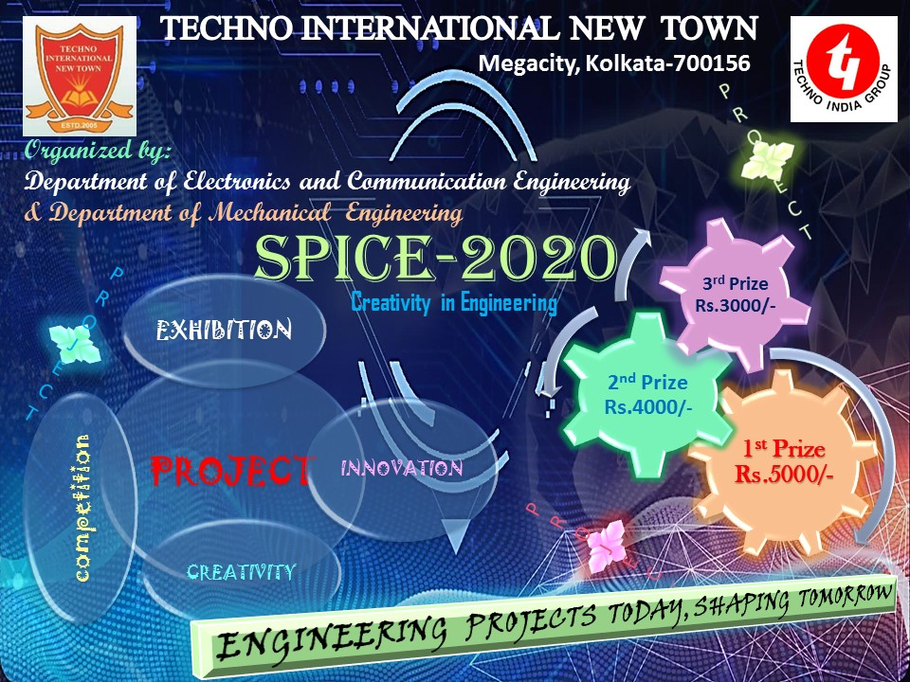

**Techno International New Town**  

Megacity, Kolkata 700156

Registration Form for SPICE - 2020

(to be submitted by 31 December 2019)

Team Name: _______________________________________________________

Organization: _______________________________________________________

Name of Team Members (in “BLOCK” Letters)

|  |  |  |  |  |
| --- | --- | --- | --- | --- |
| Sl. No. | Name of Members | Department | e-mail Id | Phone No. |
| 1 |  |  |  |  |
| 2 |  |  |  |  |
| 3 |  |  |  |  |
| 4 |  |  |  |  |

Project Objective/ Abstract: (Within Three hundred Words, separate sheets may be used)

……………………………………………………………………………………………………………………………………………………………………………………………………………………………………………………………………………………………………………………………………………………………………………………………………………………………………………………………………………………………………………………………………………………………………………………………………………………………………………………………………………………………….

**Registration Fees: Candidates Signature**

Rs. 300/- only per team

**1.**

**2.**

**3.**

**4.**

**Contact Persons:**

ECE Department – Prof. Joyati Chatterjee (# 9477122126, Prof. Atanu Chakraborty (# 9433764820)

ME Department – Prof. Basumitra Ghosh (# 9475236429), Prof. Arindam Roy Goswami (# 897284879)